Screenshot of Agent Execution (verbose=True)
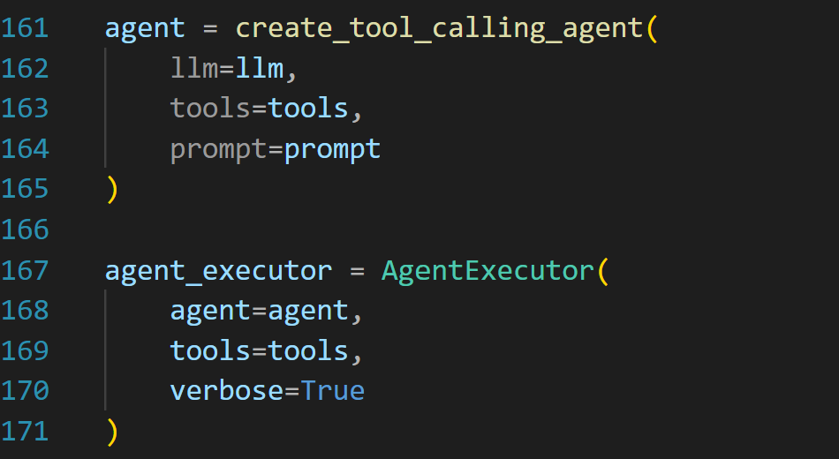

Screenshot of Outputs for all Test Cases

Query 1
I attended 72 classes out of 90. Am I eligible for exams?
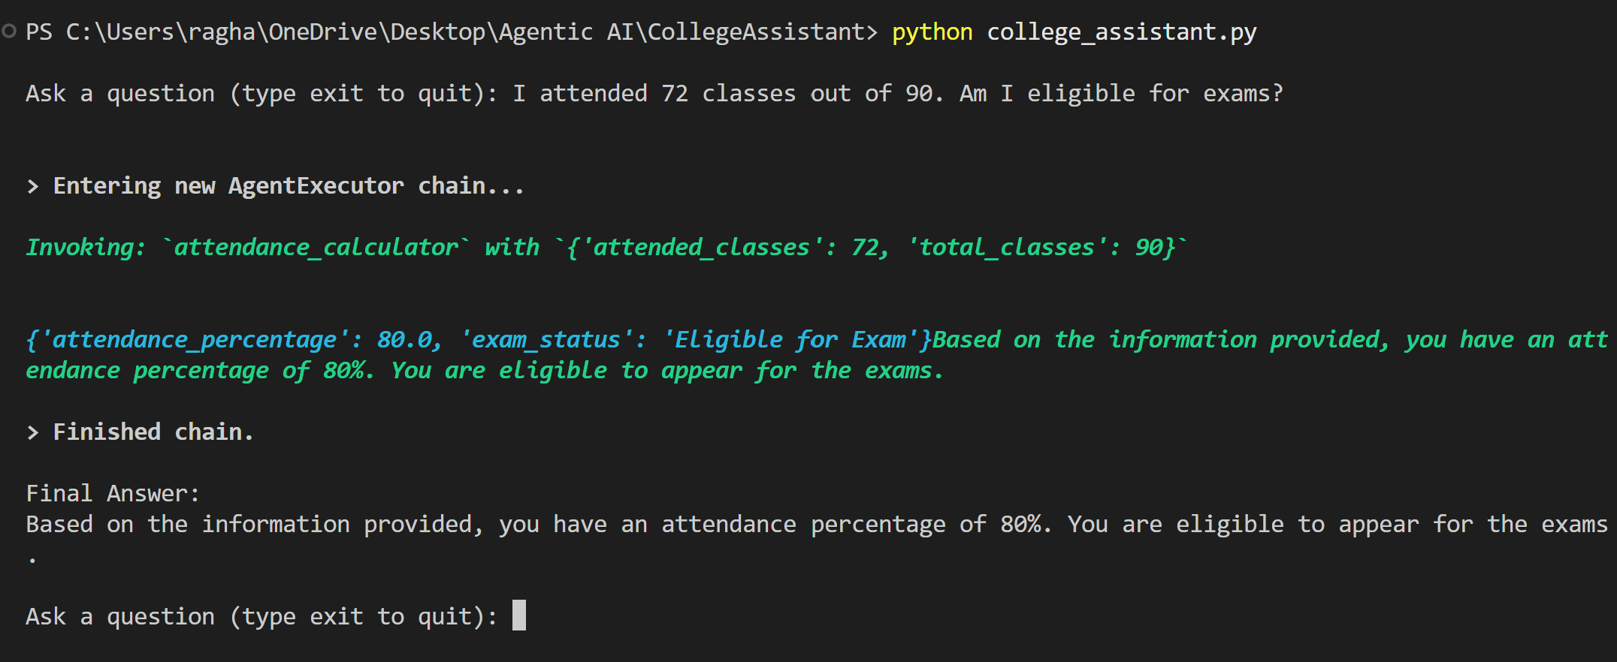

Query 2
My marks are 95, 90, 88, 91 and 87. What is my grade?
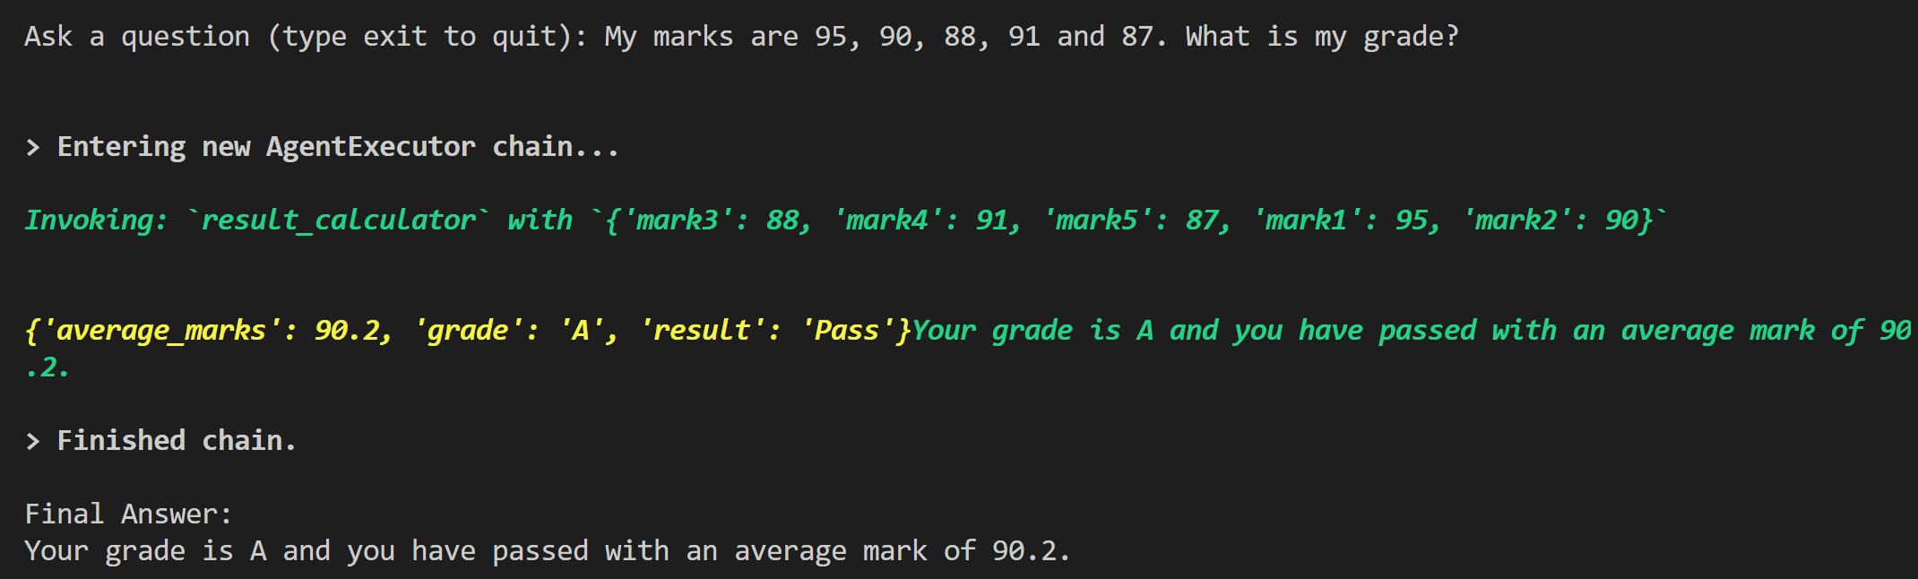

Query 3
My course fee is 50000 and I have paid 35000. How much fee is pending?
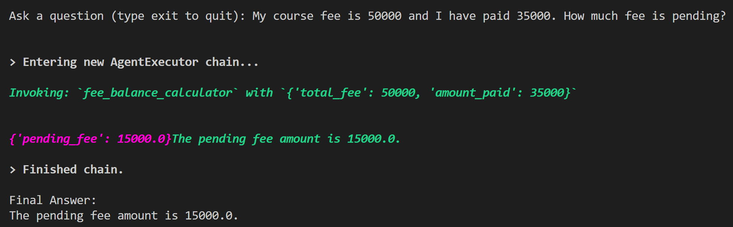

Query 4
I returned a library book 8 days late. What is the fine amount?
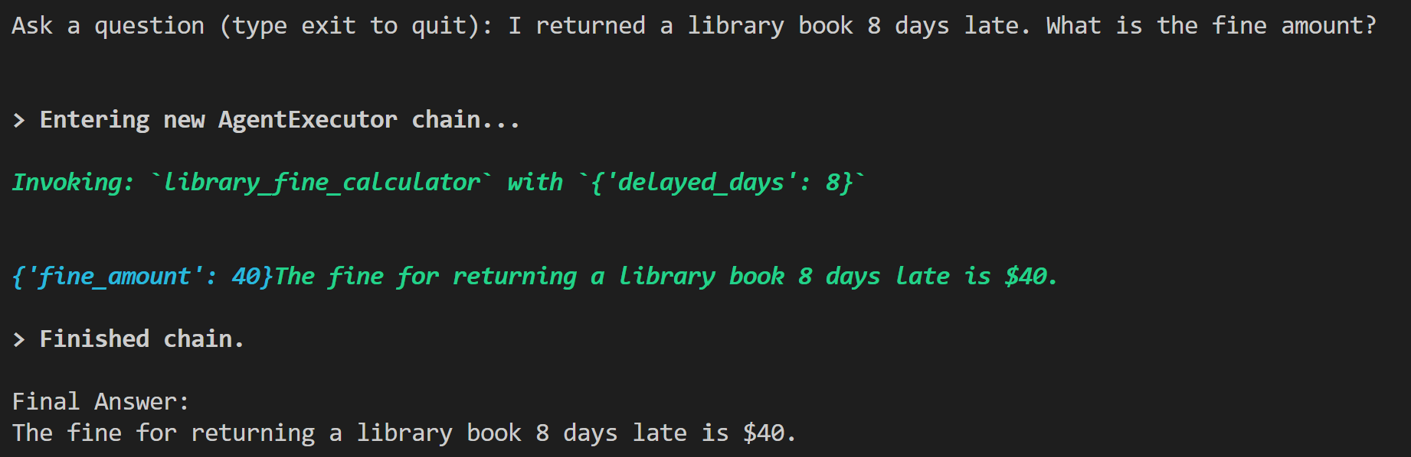

Query 5
Hostel fee is 6000 per month and I stayed for 5 months. Calculate my hostel fee.
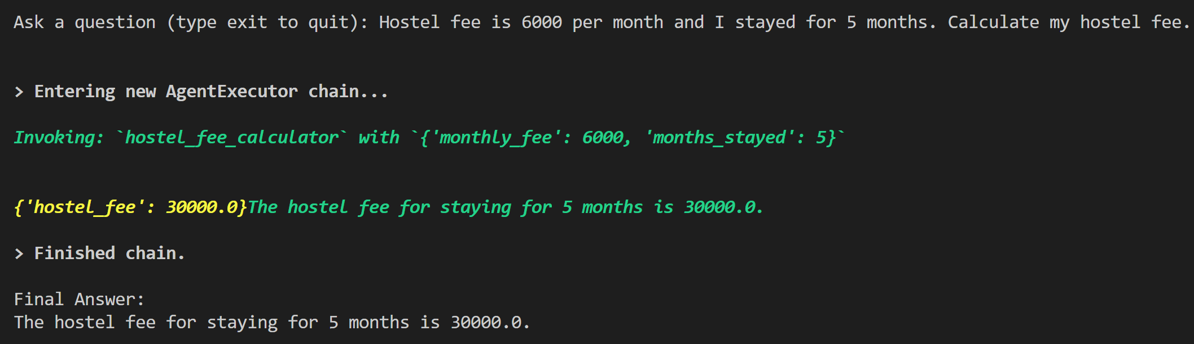

Multi-Tool Challenge
I attended 80 classes out of 100.
My marks are 90, 85, 88, 92 and 95.
My course fee is 60000 and I paid 45000.
Provide:
1. Attendance Status
2. Grade
3. Pending Fee
The agent should automatically invoke multiple tools and provide a consolidated response.
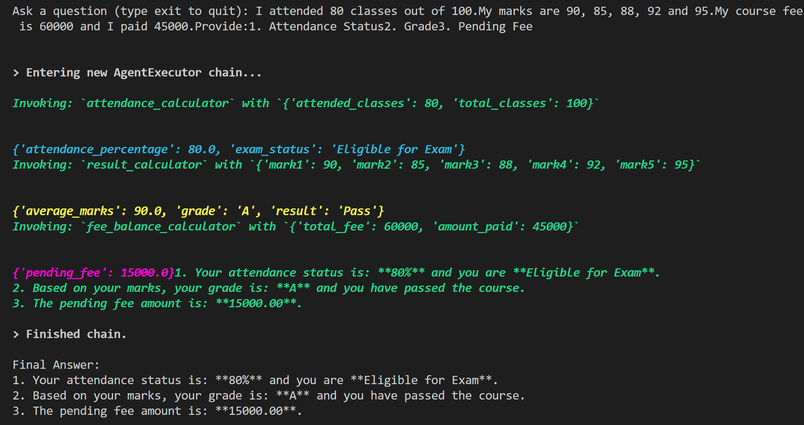

Bonus Challenge
Create a Student Information Tool that retrieves student details from a Python dictionary using Student ID.

